* - [Instructor] The map method for arrays to serve special mention because it is heavily used when working with complex lists of data and when using frameworks like React.

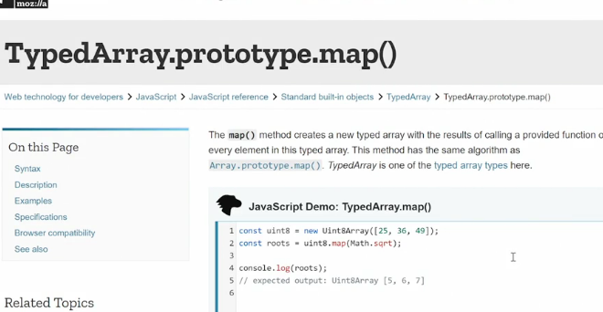

* **The map method takes an existing array, then does something to each of the items in the array and returns each of those items into a new array.**
* In contrast, for each array method we looked at earlier loops through the array but doesn't create anything unless we explicitly tell it to and nothing is ever returned into something else.
* So **if we need to create a new array with the items from an existing array** and **we want to change those items in the process, we use the map method**.
* Looking at our foreach example from earlier, you see we use the foreach loop to loop through each of the items.
* Then we create a new element for each item, insert the item value into that element the "li" and then we append that item immediately to the stuff list ul so that it appears.
* But in many cases we may want to do this differently.
* Maybe we want to first create those new elements and then maybe do something else and then append them directly to create element.
* For that purpose, we would use the map method instead.
* So let's see how this would wire together.
* **First, I want to change this foreach loop into a map loop*.***
* To do that*,* ***I need to create a new constant and place the map loop inside that constant.***
* So I'll say const, we'll call this one stuffItems equals.
* Then right now we have stuff foreach, so I'll change that to stuff map.
* And then change this to map array method.
* All right, now we want to do the same things.
* We want to create that list item and populate the list item with the value of the individual item we're looking at.
* ***But instead of appending it directly to the stuff list ul immediately, we want to return this new list item back to stuffItems to create a new array.***
* So I'll cut this out because we'll use it later.
* And then I'll say return listItem.
* Now, when we run this, we'll get a new array called stuffItems that has each of the items from our stuff array, but with an li appended around it.
* We can then try to output all this stuff.
* So we'll say console.
* log, and then we'll say stuff first, and then console.
* log stuffItems.
* That's the new array we just created using map.
* Save that, go into our console.
* And here you see we now have two arrays.
* The first one has just items.

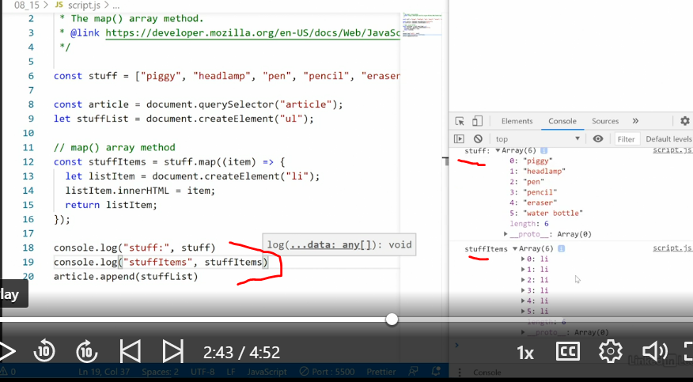

* The second one has list items and inside each list item, we scroll down here you're going to see the value of each of these list items is whatever it is.
* So in this case, indexHTML, piggy, and so on.
* And each of these list items is a proper object inside the DOM that we can then apply somewhere.
* ***Now that we have a new array with the list items, we need to use foreach loop to loop through each of them and then append them to the stuff list ul.***
* So I'll say stuffItems.
* foreach.
* Then we grab each item, create an arrow function, and inside each item you want to grab stuff lists, that is the ul up here and append the list item to that item.
* Sorry, this is the item now, like that.
* Save, and now we get the same response as we did before.

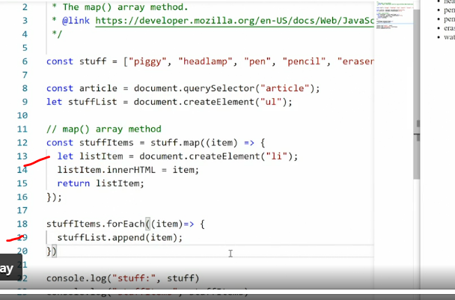

* So why on earth would I want to do this? This just made the process more complex? Well, the reality is, in many cases simply iterating through an array and outputting the content right away is not what you want to do.
* *More often than not, you want to create a more complex array first and then perform other actions on that array before you output it to the browser or do whatever you want to do with it and that's what the map method is for*.
* Now that you know how to use the map method, a caveat.
* You'll see the map method used a lot in modern JavaScript especially in JavaScript frameworks.
* And a lot of the time it's used to just iterate through an array just like we did with the foreach method.
* This is an anti-pattern and it should be avoided.
* **Map is specifically for when you need to create a new array to do something further with the data.**
* If you just want to iterate through an array, and then output the content right away, use a foreach loop, that's what it's for.
* *The reason people are using map like this, is quite simply that map is a trendy new tool and people like to follow trends.*
* What can I say? People do weird things sometimes.
* So **if you need to iterate through an array, use foreach.**
* **If you need to create a new array, out of an old array and do something to each of the items before you do so, then use map.**